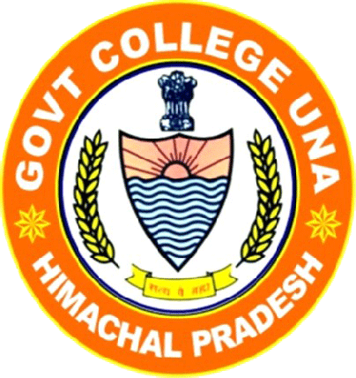Government Degree College Una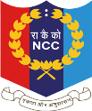
NOTICE Dated: 31/07/2023
ENROLLMENT FOR NCC ARMY WING

This is notified to all students of B.A./B.Sc./B Com. 1st year of Govt. Degree College Una that online registration form for the new enrollment in 1HP Girls’ Battalion NCC, Solan for the session 2023-24 will begin from 1st August, 2023 to 7th August, 2023 till 11:59 p.m.
Interested students can register online through Google form:

https://forms.gle/vUaeWDbadXEfWngq6

Which is also available on college website:
https://www.govtpgcollegeuna.in/
The list of screened candidates will be notified on college website. Keeping in mind that screened candidate will be called for interview and final selection will be based on Physical Fitness Test (PFT) that will be conducted after your physical presence in the institute.
Eligibility Conditions:
- Citizen of India
- Bearing good moral character
- Enrolled in this institution
- Must be medically fit
- Height : 155 cm or above
- Hearing must be good
- Speech must be without impediment
For Further details Contact: Lt (Dr.) Monika Khanna, Mobile: 8894556265
Lt (Dr.) Monika Khanna
1HP Girls’ Battalion NCC, Solan Principal
Govt College Una

